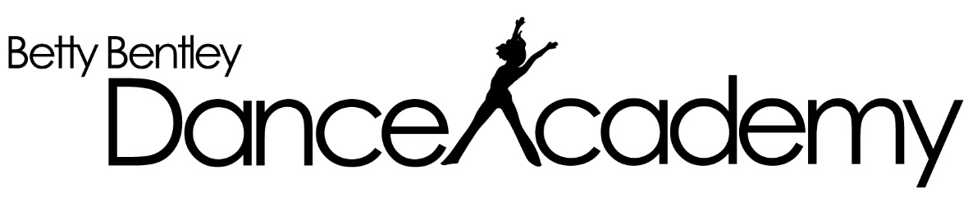

2022 Important Dates – Willetton Studio

Term Dates
Term 1: Monday January 31st – Saturday 9th April (10 weeks) Fees due Saturday 12th Feb
Term 2: Monday April 25th - Saturday July 2nd (10 weeks) Fee due Saturday 7th May
Term 3: Monday July 18th - Saturday Sept 24th (10 weeks) Fees due Saturday 30th July
Term 4: Monday October 10th -3rd December (9 weeks) Fees due Saturday 22nd Oct

Examination Dates
Jazz Exams: July 2022 Fee due Thursday 1st April
Tap Exams: July 2022 Fee due Thursday 1st April
Classical Exams: October 2022 Fees due Saturday 31st July

Concert Dates
Dress Rehearsal: Monday 28th November
Concert: Sunday 4th December Matinee & Evening Performance

Costume Registration & Deposits due Saturday 4th JUNE
Forms and Deposit Envelopes will be distributed between May 9 – 14. If you do not receive yours by then please speak to Sharon, our Receptionist or one of our teachers

Costume balance payments TBA

