Willetton Studios
Corner High Road & Augusta Street
Port Kennedy Studios
Corner Helmshore Way & Stockton Street
Phone: 0438 466 303
Email: donna@bettybentleydance.com.au

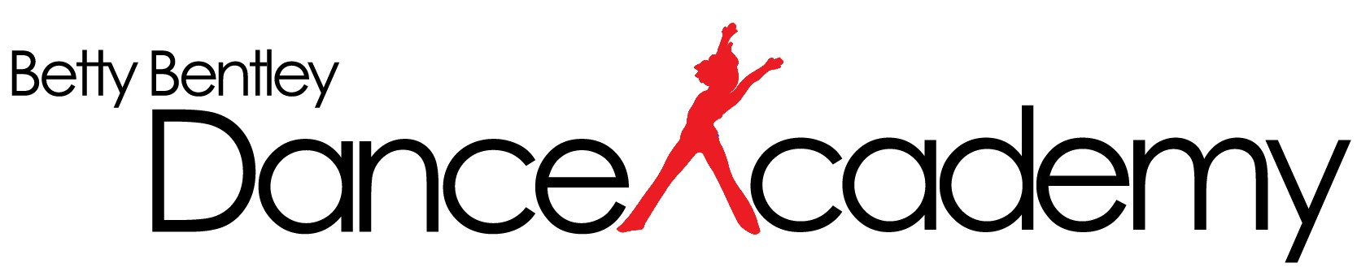

Dear Parents & Students
Term 1 2022

Welcome to 2022. With the growing concerns over the spread of the Coronavirus, we felt it timely to communicate how we are responding as management of the dance school. We will be implementing recommendations set out by the Department of Heath WA and ask all parents, carers, and students to follow these recommendations.
Here is an updated list of the procedures we are implementing:

- In line with the WA State Government Health guidelines to enter our premises proof of double vaccination will be required. This is required to all over 16 years of age including students.
Please do not harass the staff over this requirement, they are just doing their part in complying with State regulations

- Anyone entering the studio must wear a mask and register with the SafeWA app or sign in manually. Please do the right thing and log in.

- Face masks for all over 12 years.

- All classes will remain drop off and pick up only. This will mean no siblings or parents will be able to stay in the studio reception. Where necessary i.e., to buy uniforms or pay fees all the above requirements must be adhered to and the stay in reception must be kept short.

- Drop off to the reception area 5 minutes prior to class start time if possible.

- Pick up (weather permitting) from the side doors of studios being used. Please drive safely in the parking area.

- Students who are unwell with any cold or flu-like symptoms are required to stay home until all symptoms have cleared. Students showing symptoms will be sent home.

STEPS THE DANCE SCHOOL IS TAKING TO MINIMISE THE IMPACT OF COVID-19
- Speaking to all students about the need for additional hygiene practices such as
  - Thorough washing of hands
  - Covering mouth when coughing or sneezing
  - Avoiding touching their face
  - No sharing of drink bottles or food
  - Signs on all toilet doors to remind students about handwashing and instructions for thorough hand washing displayed in all bathrooms
  - Continued provision of hand soap and paper towels in all toilet blocks
  - Additional cleaning of surfaces throughout the studios.

- We will do as much as is reasonably possible to keep students the recommended distance from each other.

- Water bottles should have names on them so that mistakes are not made and bottles inadvertently shared. Studio cups and glasses are not to be used. Please bring your own bottle especially in these hotter months when staying hydrated is an absolute must.

I thank you for your continued support in 2022.
Thank you
Donna

